Function definitions



1. Signature, purpose and stub

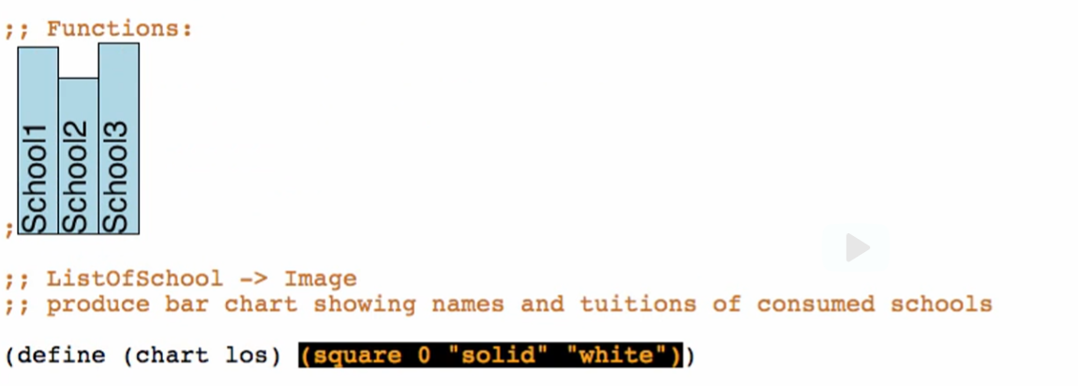

1. Examples

Base case:



Other cases:

1 element

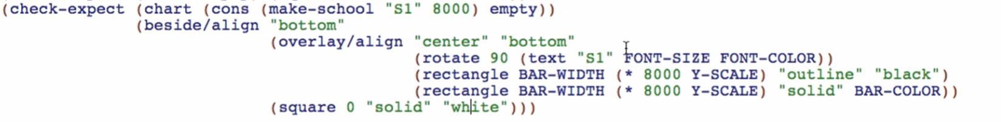

2 elements

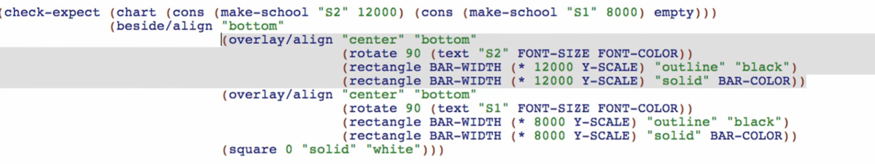

Why writing examples are important? (esp. for hard examples)

* Helps us figure out what we want the function to do
* Helps us remember the names of primitives we need
* Helps us get details like order of arguments right

This makes the next steps of the recipe to be easier!